Using Privilege Analysis ( capture privilege )

## Create Users, Roles, Tables and Grant Privileges and Roles

Use SQL*Plus to connect as system to create the users JIM and TOM , roles, and grant privileges and or roles.

Connect as SYSTEM:

**. oraenv**

**[enter cdb1 at the prompt]**

**sqlplus system/oracle@localhost:1521/pdb1**

Create users.

**create user jim identified by jim;  
create user tom identified by tom;  
create user ann identified by ann;**

Create roles.

**create role HR_MGR;  
create role SALES_CLERK;   
create role ANALYST;**

Grant privileges.

**grant create session to jim, tom, ann;**

**grant select, update, delete, insert on hr.employees to HR_MGR;  
grant HR_MGR to JIM;  
  
grant select on sh.sales to SALES_CLERK;  
grant SALES_CLERK to TOM;   
  
grant select any table to ANALYST;  
grant ANALYST to ann;**

## Define the Captures

In this section, you will prepare the three types of captures.

### Define the capture of privileges used by all users.

Define the capture of privileges used by all users. Use the DBMS_PRIVILEGE_CAPTURE package and the CREATE_CAPTURE procedure with the appropriate type of capture.

**exec SYS.DBMS_PRIVILEGE_CAPTURE.CREATE_CAPTURE ( -   
        name           =>  'All_privs', -   
        description    =>  'All privs used', -  
        type           =>   dbms_privilege_capture.g_database)**

### Define the capture of privileges used through roles.

Define a capture of privileges used by roles HR_MGR, ANALYST, and SALES_CLERK. Use the DBMS_PRIVILEGE_CAPTURE package and the CREATE_CAPTURE procedure with the appropriate type of capture and the list of roles analyzed.

**exec SYS.DBMS_PRIVILEGE_CAPTURE.CREATE_CAPTURE ( -   
        name           => 'Role_privs', -  
        description    => 'Privs used by HR_MGR, SALES_CLERK', -  
        type           =>  dbms_privilege_capture.g_role, -  
        roles          =>  role_name_list('HR_MGR', 'SALES_CLERK','ANALYST'))**

### Define the capture of privileges used through contexts.

Define a capture of privileges used by the user TOM or by the specific role SALES_CLERK.

Use the DBMS_PRIVILEGE_CAPTURE package and the CREATE_CAPTURE procedure with the appropriate type of capture, the list of roles analyzed and the context in which the analysis would take place once started.

**exec SYS.DBMS_PRIVILEGE_CAPTURE.CREATE_CAPTURE ( -   
        name           => 'Special_capt', -   
        description    => 'Special', -  
        type           =>  dbms_privilege_capture.g_role_and_context, -  
        roles          =>  role_name_list('SALES_CLERK'), -  
        condition      => 'SYS_CONTEXT(''USERENV'',''SESSION_USER'')=''TOM''')**

### List the existing captures.

Use the DBA_PRIV_CAPTURES view.  
**Note:** You may see different role ID results.   
**COL name     FORMAT A12  
COL type     FORMAT A16  
COL enabled  FORMAT A2  
COL roles    FORMAT A24** **COL context  FORMAT A43  
  
select name, type, enabled, roles, context  
from   dba_priv_captures;**

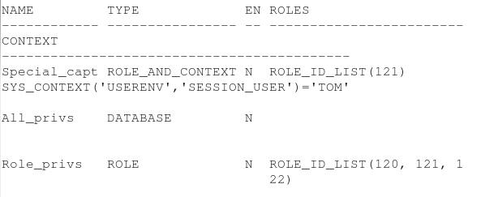

## Start Privilege Captures and Analyze

### Start and analyze the capture of privileges used by all users.

Start capturing the privileges while users are performing their daily work using privileges. Use the ENABLE_CAPTURE procedure.  **exec SYS.DBMS_PRIVILEGE_CAPTURE.ENABLE_CAPTURE (name => 'All_privs')  
  
exit  
[Note that you must exit SQL*Plus and then relaunch SQL*Plus in the next step, otherwise you may see unintended results in the privilege analysis views in later steps of this tutorial.]**

The users JIM, TOM, and ANN run SQL statements using privileges. JIM, and ANN who select rows from HR.EMPLOYEES table and TOM who selects rows from SH.SALES table.

**sqlplus jim/jim@localhost:1521/pdb1  
select * from hr.employees where salary < 3000;  
  
connect tom/tom@localhost:1521/pdb1  
select * from sh.sales where amount_sold < 6.42 and cust_id = 6452;  
  
connect ann/ann@localhost:1521/pdb1  
select * from hr.employees where salary > 3000 and rownum <=5 order by salary desc;**

**exit  
[Note you must exit SQL*Plus and then relaunch SQL*Plus in the next step.]**

Stop capturing. Use the DISABLE_CAPTURE procedure. 

**sqlplus system/oracle@localhost:1521/pdb1  
exec SYS.DBMS_PRIVILEGE_CAPTURE.DISABLE_CAPTURE (name => 'All_privs')**

Generate the capture results. It may take a few minutes. Use the GENERATE_RESULT procedure.  **exec SYS.DBMS_PRIVILEGE_CAPTURE.GENERATE_RESULT (name => 'All_privs')**Display the object privileges used during the capture period. Use the DBA_USED_OBJPRIVS view.  **COL username FORMAT A10  
COL object_owner FORMAT A12  
COL object_name FORMAT A30  
COL obj_priv FORMAT A25  
  
select username, object_owner, object_name, obj_priv  
from   dba_used_objprivs  
where  username in ('JIM', 'TOM')  
and    object_name in ('SALES' , 'EMPLOYEES');**

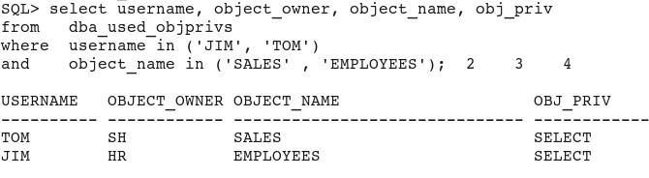

Display the privileges used by ANN. Use the DBA_USED_PRIVS view.  Does Ann, or the ANALYST role, really need the SELECT ANY TABLE privilege? **select username, used_role, sys_priv, object_name FROM dba_used_privs  
where  username ='ANN' and object_name = 'EMPLOYEES';**

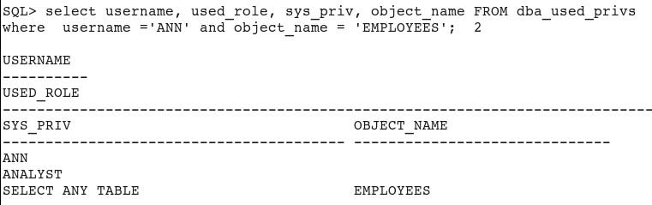

Display the system privileges used. Use the DBA_USED_SYSPRIVS view.  **select username, sys_priv FROM dba_used_sysprivs  
where  username IN ('JIM', 'TOM', 'ANN');**

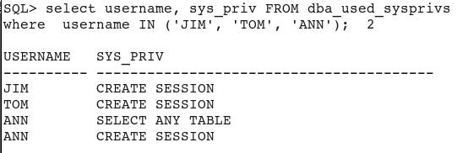

Display the path of the privileges used if the privileges were granted to roles, and roles to users. Use the DBA_USED_OBJPRIVS_PATH view.  **COL object_name FORMAT A12  
COL path FORMAT A32  
COL obj_priv FORMAT A10  
  
select username, obj_priv, object_name, path  
from   dba_used_objprivs_path   
where  username IN ('TOM','JIM','ANN')   
and    object_name IN ('SALES','EMPLOYEES');**

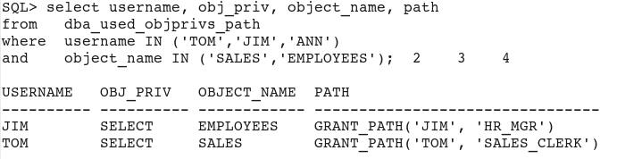

JIM is granted select, update, delete, insert privileges on HR.EMPLOYEES table through HR_MGR role. He used only the SELECT privilege thus far.  
Use the DBA_UNUSED_PRIVS view to list the unused privileges. You can decide which of the unused privileges can be revoked if necessary.  **select username, sys_priv, obj_priv, object_name, path  
from   dba_unused_privs  
where  username='JIM'  
and object_name = 'EMPLOYEES';**

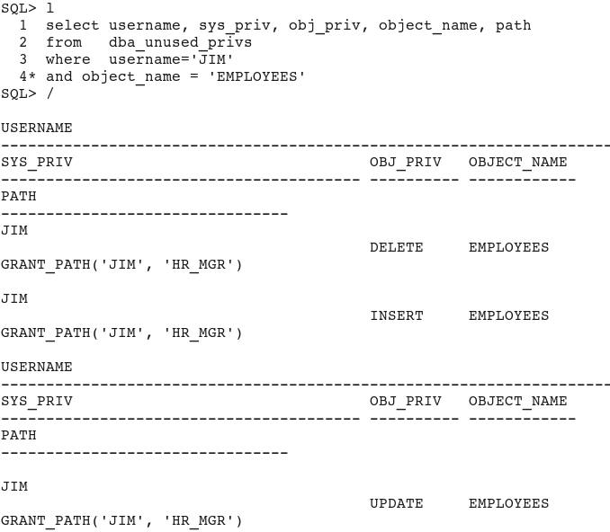

### Start and analyze the capture of privileges used through roles.

Delete the previous capture so as to remove all previous captured information from the views. Use the DROP_CAPTURE procedure.  **exec SYS.DBMS_PRIVILEGE_CAPTURE.DROP_CAPTURE (name => 'All_privs')**Verify that there is no data left from the All_privs capture. Use the DBA_UNUSED_PRIVS view. There should be no rows returned by the query. **select username, sys_priv, obj_priv, object_name, path  
from   dba_unused_privs  
where  username='JIM';**Start capturing the privileges while users are performing their daily work using roles.  **exec SYS.DBMS_PRIVILEGE_CAPTURE.ENABLE_CAPTURE (name => 'Role_privs')**

The users JIM and TOM run SQL statements using privileges. JIM who selects rows from HR.EMPLOYEES table and TOM who selects rows from SH.SALES table.

**connect jim/jim@localhost:1521/pdb1  
select * from hr.employees where salary < 3000;  
  
connect tom/tom@localhost:1521/pdb1  
select * from sh.sales where amount_sold < 6.42 and cust_id = 6452;**

Stop capturing.   
  
**connect system/oracle@localhost:1521/pdb1  
exec SYS.DBMS_PRIVILEGE_CAPTURE.DISABLE_CAPTURE (name => 'Role_privs')**Generate the capture results. **exec SYS.DBMS_PRIVILEGE_CAPTURE.GENERATE_RESULT (name =>'Role_privs')**Display the object privileges used by the roles HR_MGR and SALES_CLERK during the capture period. **COL used_role FORMAT A14**  
  
**select  username, object_owner, object_name, obj_priv, used_role  
from    dba_used_objprivs  
where   used_role in ('HR_MGR', 'SALES_CLERK');**

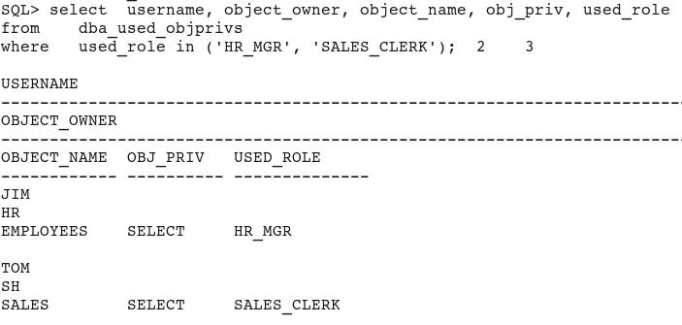

Display the system privileges used by the roles HR_MGR and SALES_CLERK during the capture period.  **select username, sys_priv, used_role   
from dba_used_sysprivs  
where used_role in ('HR_MGR', 'SALES_CLERK');**

No rows are returned because no system privileges were used.

HR_MGR is granted select, update, delete on HR.EMPLOYEES table. The role used by JIM during the capture period used the SELECT privilege.  
The unused privileges are visible in DBA_UNUSED_PRIVS view. You can decide which of the unused privileges or role can be revoked if necessary.  **COL username FORMAT A12  
COL path FORMAT A32  
COL object FORMAT A10  
COL sys_priv FORMAT A10  
COL obj_priv FORMAT A10  
  
select sys_priv, obj_priv, object_name, path  
from   dba_unused_privs  
where  rolename IN ('HR_MGR', 'SALES_CLERK');**

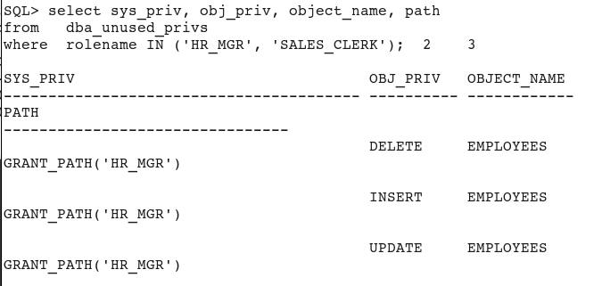

### Define the capture of privileges used through contexts.

Delete the previous capture so as to remove all captured information from the views.

**exec SYS.DBMS_PRIVILEGE_CAPTURE.DROP_CAPTURE (name => 'Role_privs')**

Verify that there is no data left from the Role_privs capture. There should be no rows returned by the query. **select sys_priv, obj_priv, object_name, path  
from   dba_unused_privs  
where  rolename IN ('HR_MGR', 'SALES_CLERK');**

Start capturing the privileges while users are performing their daily work using privileges.

**exec SYS.DBMS_PRIVILEGE_CAPTURE.ENABLE_CAPTURE (name => 'Special_capt')**

The users JIM and TOM run SQL statements using privileges. JIM selects rows from HR.EMPLOYEES table and TOM selects rows from SH.SALES table.

**connect jim/jim@localhost:1521/pdb1  
select * from hr.employees where salary < 3000;  
  
connect tom/tom@localhost:1521/pdb1  
select * from sh.sales where amount_sold < 6.42 and cust_id = 6452;**

Stop capturing.

**connect system/oracle@localhost:1521/pdb1  
exec SYS.DBMS_PRIVILEGE_CAPTURE.DISABLE_CAPTURE (name =>'Special_capt')**

Generate the capture results.

**exec SYS.DBMS_PRIVILEGE_CAPTURE.GENERATE_RESULT (name => 'Special_capt')**Display the object privileges used during the capture period.  **COL username FORMAT A10  
COL owner FORMAT A8  
COL object FORMAT A16  
COL obj_priv FORMAT A10  
COL used_role FORMAT A14  
  
select  username, object_owner, object_name, obj_priv, used_role  
from    dba_used_objprivs  
where   username ='TOM' OR used_role='SALES_CLERK';**

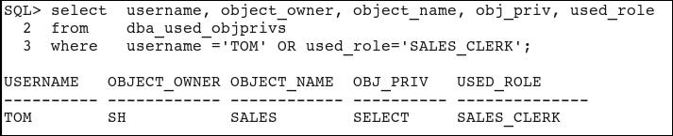

Check whether any system privileges were used. There should be no rows returned, because no system privileges were used.  **select username, sys_priv from dba_used_sysprivs;**Display the path of the privileges used if the privileges were granted to roles, and roles to users. Use the DBA_USED_OBJPRIVS_PATH view.  **COL object FORMAT A12  
COL path FORMAT A32  
COL obj_priv FORMAT A10  
  
select username, obj_priv, object_name, path  
from   dba_used_objprivs_path   
where  username IN ('TOM','JIM')   
and    object_name IN ('SALES','EMPLOYEES');**

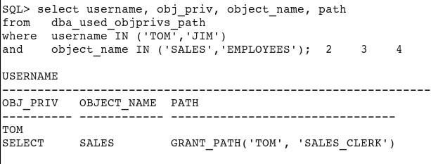

TOM is granted the select privilege on the SH.SALES table through SALES_CLERK role. He used the privilege.  
The unused privs are visible in DBA_UNUSED_PRIVS view.  
The query returns no rows, because there are no unused privileges. Therefore, there is no privilege that has been unnecessarily granted.

**select username, sys_priv, obj_priv, object_name, path  
from   dba_unused_privs  
where  username='TOM' OR rolename='SALES_CLERK';**

## Delete Captures

List all captures to delete:

**COL name     FORMAT A12  
COL type     FORMAT A12  
COL enabled  FORMAT A2  
COL roles    FORMAT A26  
  
select name, type, enabled, roles, context  
from   dba_priv_captures;**

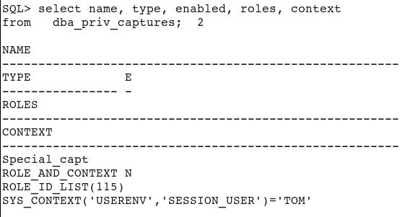

Delete all captures.

**exec SYS.DBMS_PRIVILEGE_CAPTURE.DROP_CAPTURE (name => 'Special_capt')**

## Resetting Your Environment

Delete users and roles.

**drop user jim cascade;  
drop user tom cascade;  
drop user ann cascade;  
  
drop role hr_mgr;  
drop role sales_clerk;  
drop role analyst;**